# Types of Parameters not supported:

* Cascading (for most cases I feel that the multi and single select trees are a good replacement).
* Date
* Boolean

# Types of Prompts:

**Drop Down:**

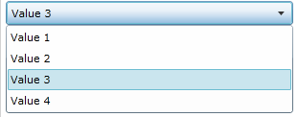

**Shopping Cart:**

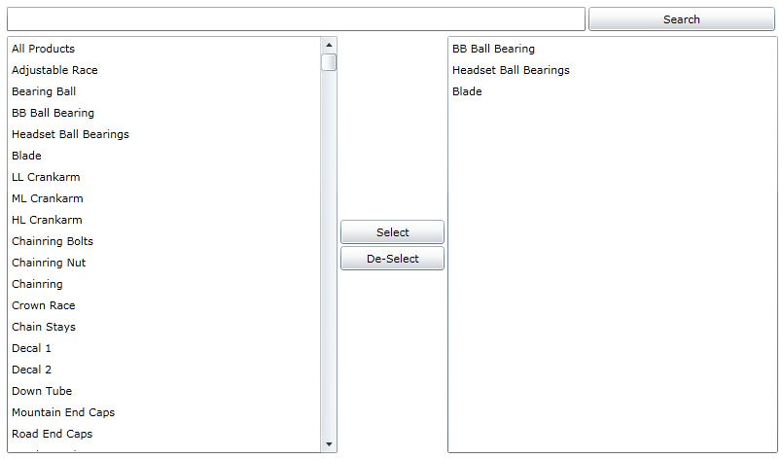

**Single Select Tree:**

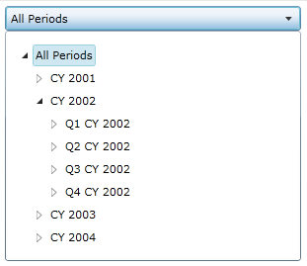

**Multi Select Tree:** 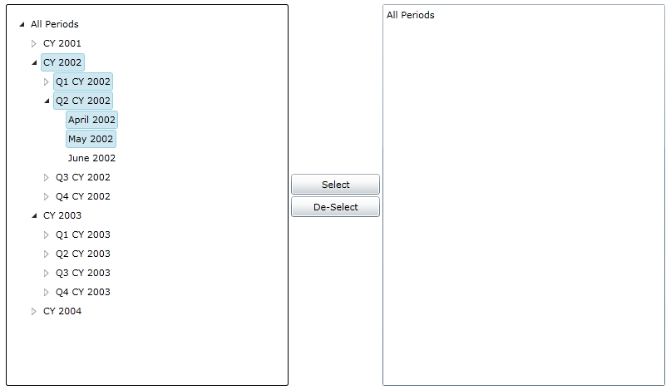

**Cascading Search:**



# Report Catalog:

* The report catalog will display the report server contents deployed to the /Reports Folder

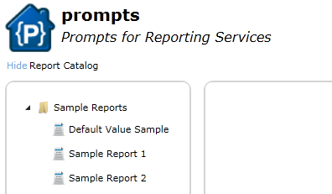

# Embedded and Global Prompts:

**Embedded Prompts:**

* Embedded Prompts are regular reporting services parameters.

**Types of Embedded Prompts:**

* Drop Down: Multi value = false.
* Shopping Cart: Multi value = true.
* Text input: No available items.

**Global Prompts:**

* A report that is deployed to the report server’s “Prompt Reports” folder that the actual report will reference.
  + To reference the global prompt in the report add 2 parameters with no available items: 1. Value Parameter: Same name as the Prompt Report. Ex. Calendar. 2. Label Parameter: Same name as Prompt Report + _Label. Ex. Calendar_Label.
    - The Value Parameter and Label Parameter need to have the same multi-value flag.

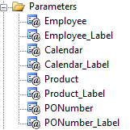

* + The Prompt of the value parameter will be used as name displayed.

**Types of Global Prompts:**

* Drop Down: Value Parameter and Label Parameter Multi value = false && prompt report only has a single parameter.
* Shopping Cart: Value Parameter and Label Parameter Multi value = true && prompt report only has a single parameter
* Single Select Tree: Value Parameter and Label Parameter Multi value = false && prompt report uses cascading parameters.
* Shopping Cart Tree: Value Parameter and Label Parameter Multi value = true && prompt report uses cascading parameters.
* Cascading Search: Value Parameter and Label Parameter Multi value = true && prompt report has 2 parameters. 1. Search parameter, no available values. 2. Result parameter: available values are dependent on Search Parameter.